Ansible Assignment-4
Use the playbooks from ansible assignment 2 and 3. Write the playbooks in ansible role format.

- Follows the tree structure of folder
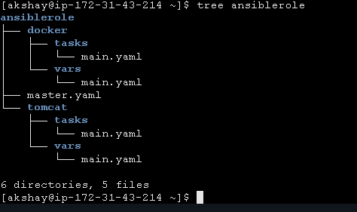

- Master.yaml file
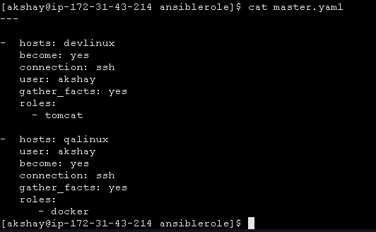

- tomcat -> tasks -> main.yaml
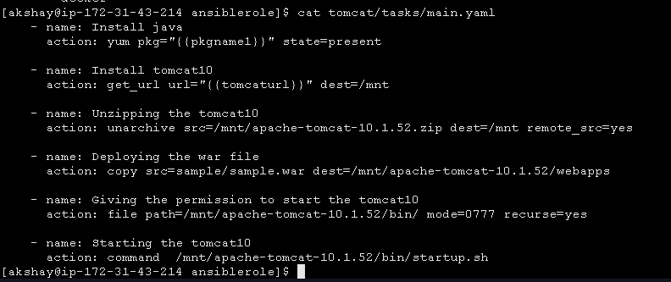

- tomcat -> vars -> main.yaml

- docker -> tasks -> main.yaml
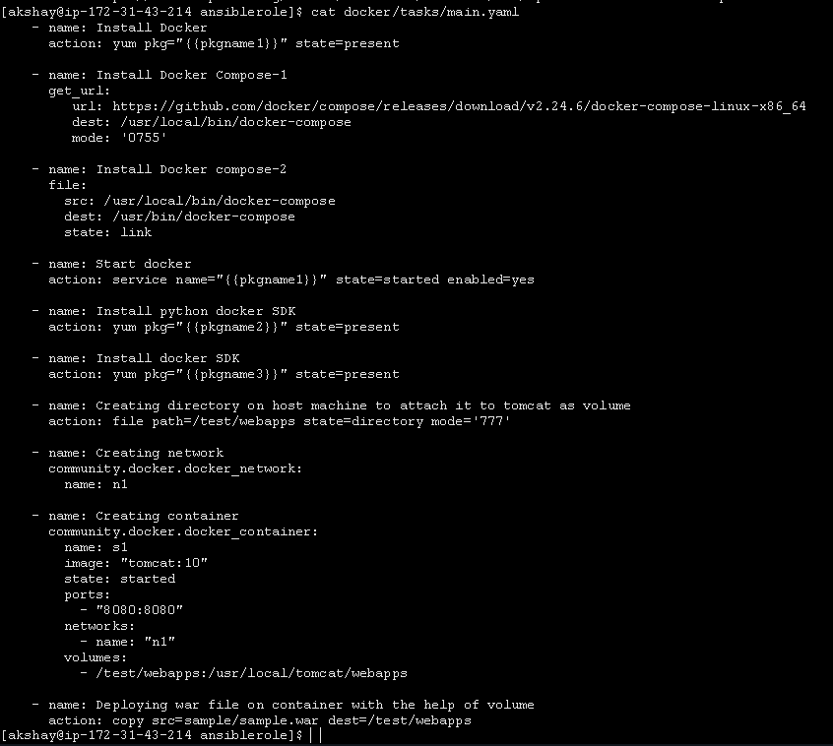

- docker -> vars ->main.yaml
